Lab assignment- 1.5
NAME: G MANOHARREDDY
HALL-TICKET :2303A51325
TASK-0
Install and configure GitHub Copilot in VS Code. Take screenshots of each step.
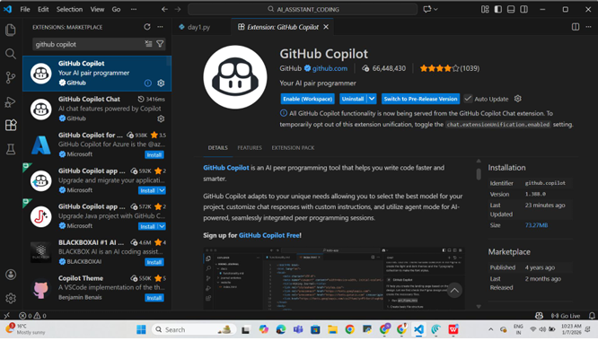
Task 1: AI-Generated Logic Without Modularization(reversing a string)
Prompt: String Reversal Without Functions
Code and output:
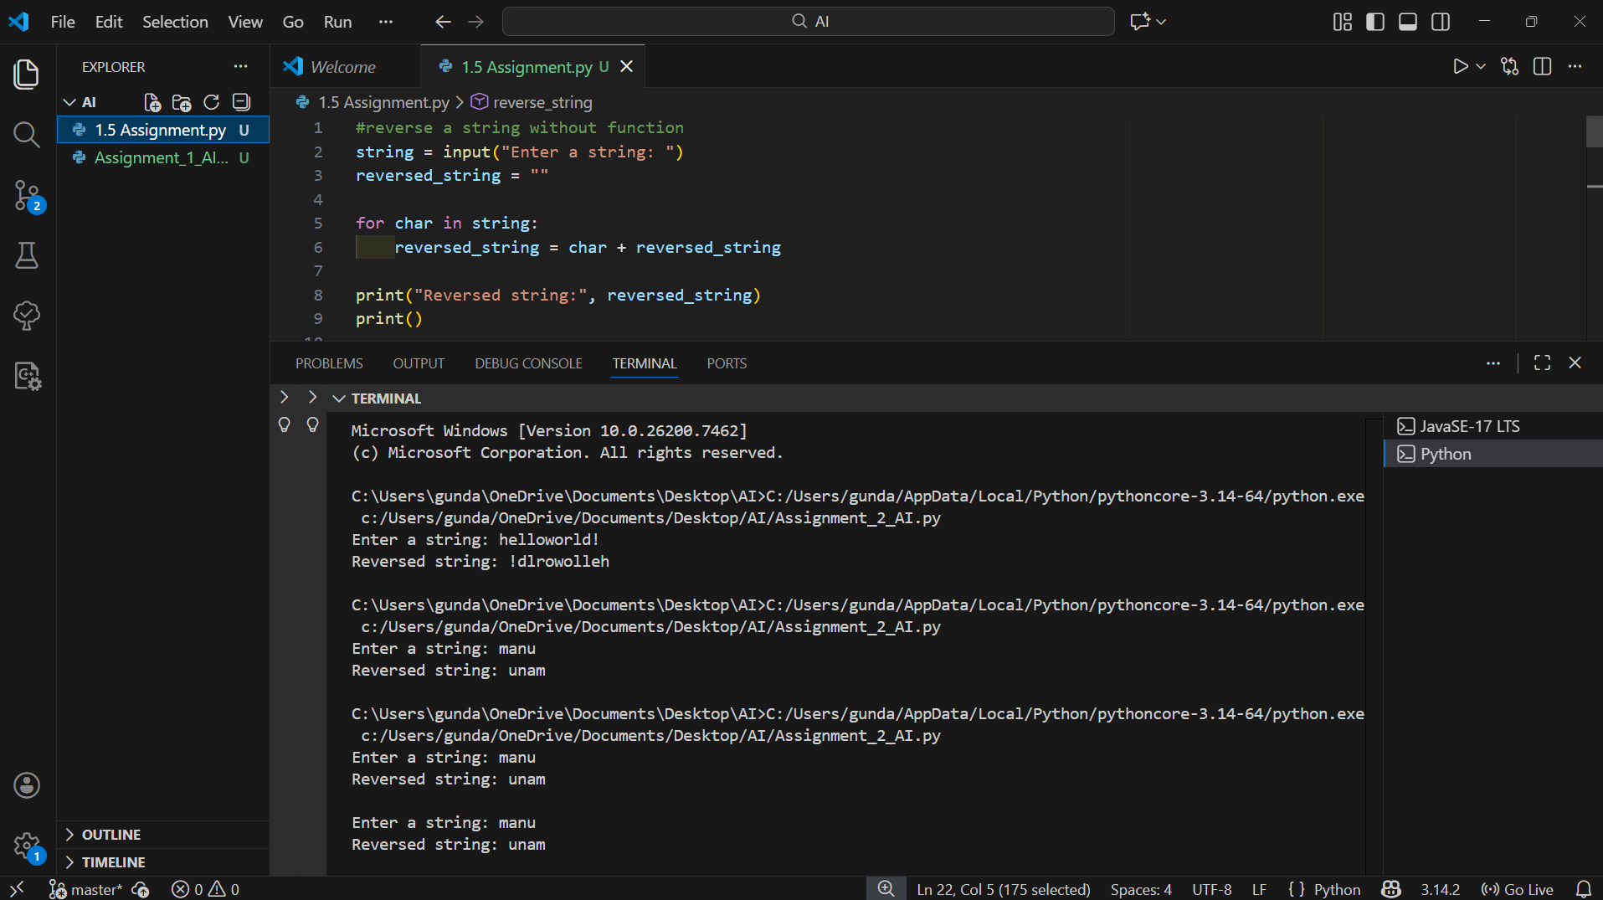
Explanation : In this task, GitHub Copilot generated a Python program that reverses a string without using any user-defined functions.
The program accepts input from the user and uses a loop to reverse the string directly in the main code.
Task 2: Efficiency & Logic Optimization
Prompt : Readability Improvement
Code and output:
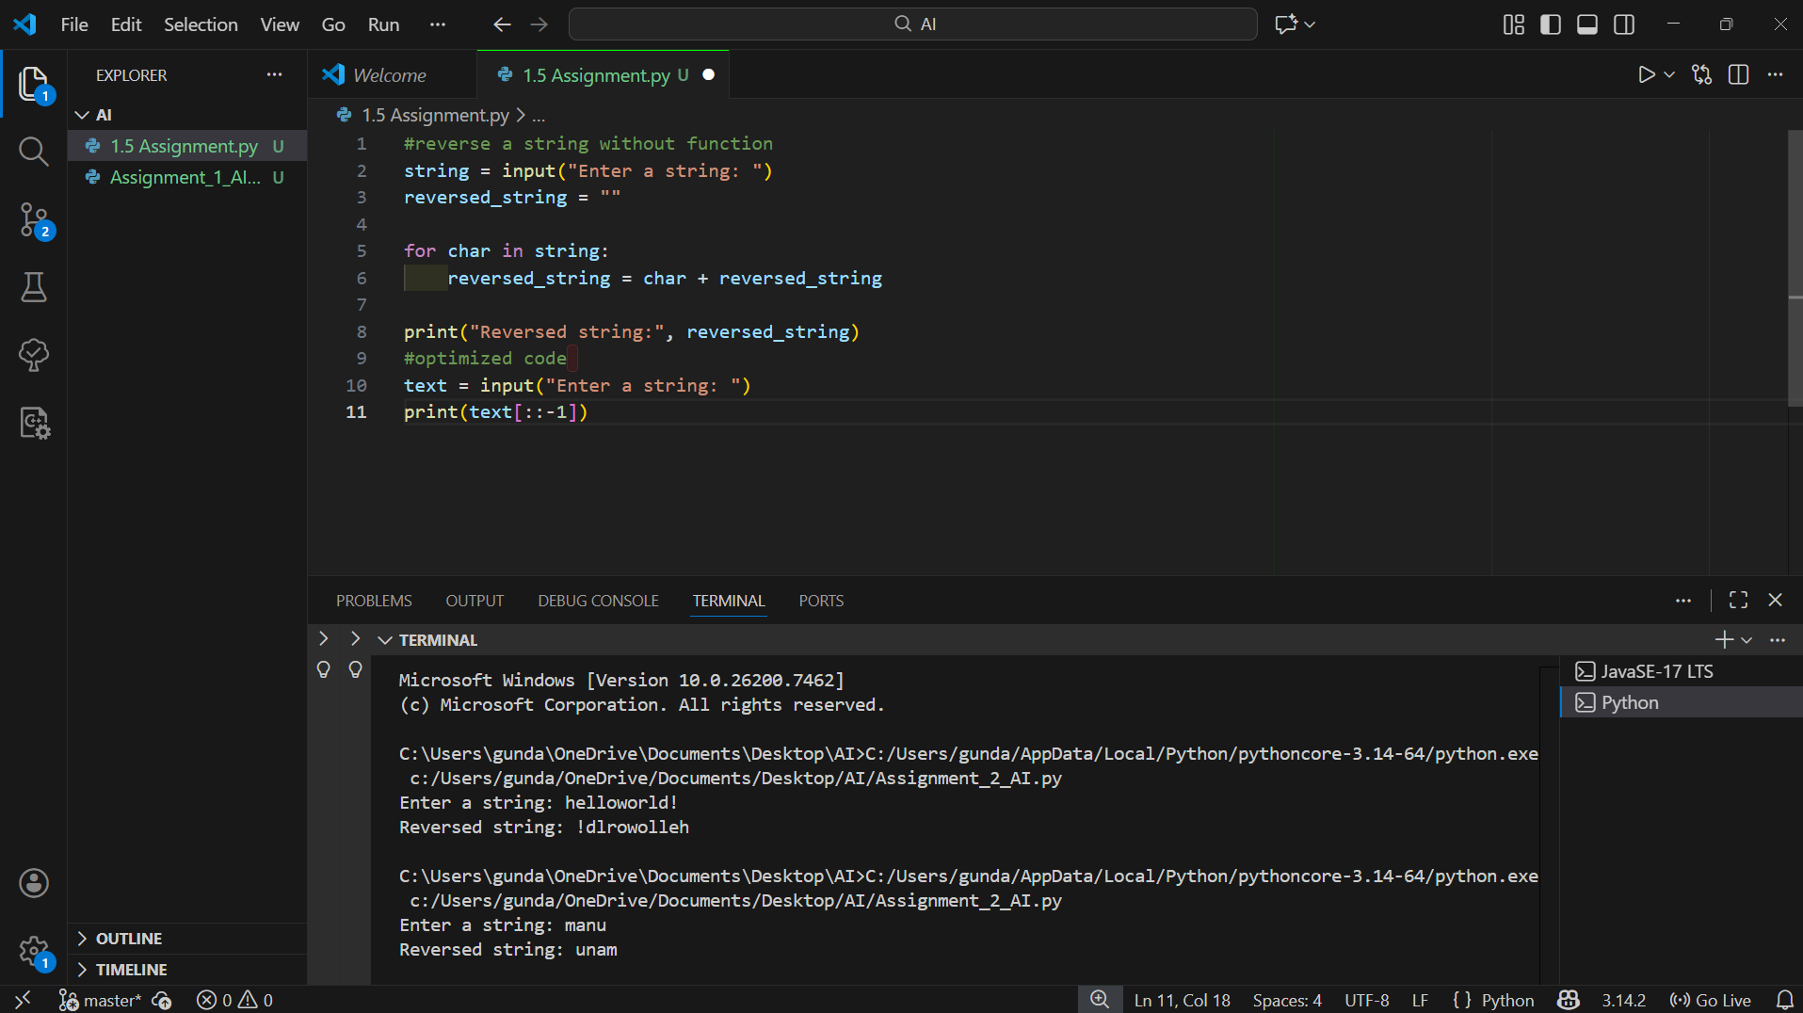
Explanation
The Copilot-generated code from Task 1 was optimized to improve readability and efficiency.
Unnecessary variables and loops were removed, and Python slicing was used to reverse the string.
Task 3: Modular Design Using AI Assistance
Prompt: String Reversal Using Functions
Code and output:
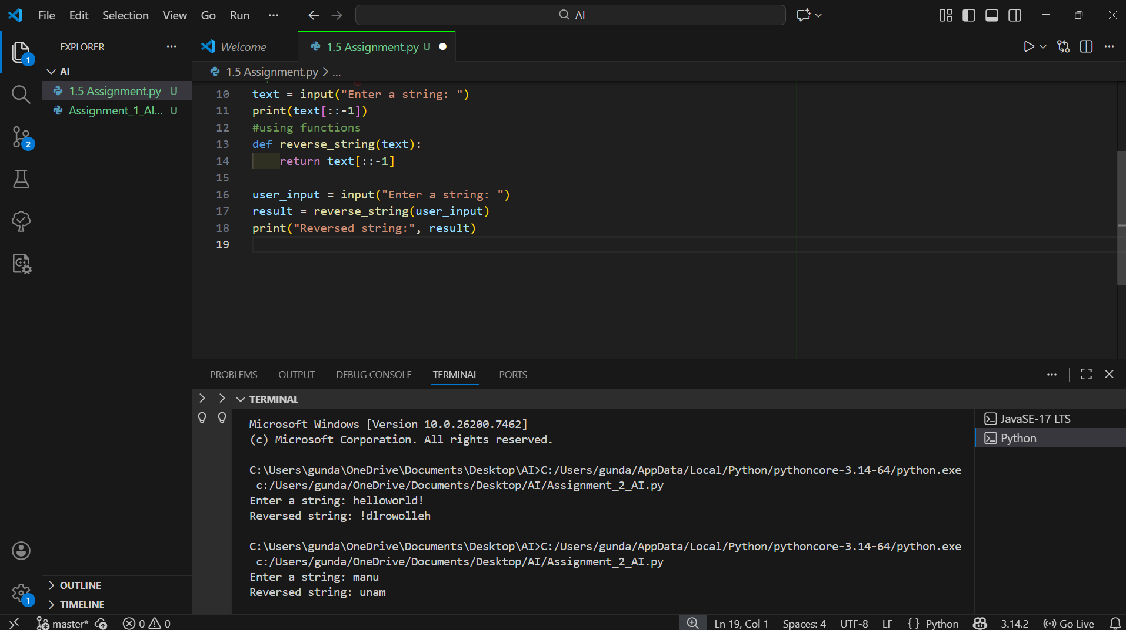
Explanation
In this task, GitHub Copilot generated a function-based program.
The string reversal logic is placed inside a user-defined function, making the code reusable and easy to maintain.
Task 4: Comparative Analysis – Procedural vs Modular Approach (With vs
Without Functions)
Prompt: Write a short analytical report comparing string reversal code with functions and without functions
Explain which approach is better and why
Analytical Report
The procedural approach (without functions) is simple and useful for small programs or beginners. However, as the program size increases, this approach becomes difficult to manage, debug, and reuse.
The modular approach (with functions) improves code clarity and organization. It allows the same logic to be reused in multiple parts of an application and makes debugging easier. Function-based programs are more maintainable and suitable for real-world and large-scale applications.
Conclusion:
Using functions is a better design choice for scalable, readable, and maintainable software development.
Task 5: AI-Generated Iterative vs Built-in String Reversal
Prompt : Generate a comparison table or short analytical report comparing string reversal code written
1) without functions (procedural approach)
2) with functions (modular approach) Compare them based on code clarity, reusability,debugging ease, maintainability, and suitability for large-scale applications
Code and output:
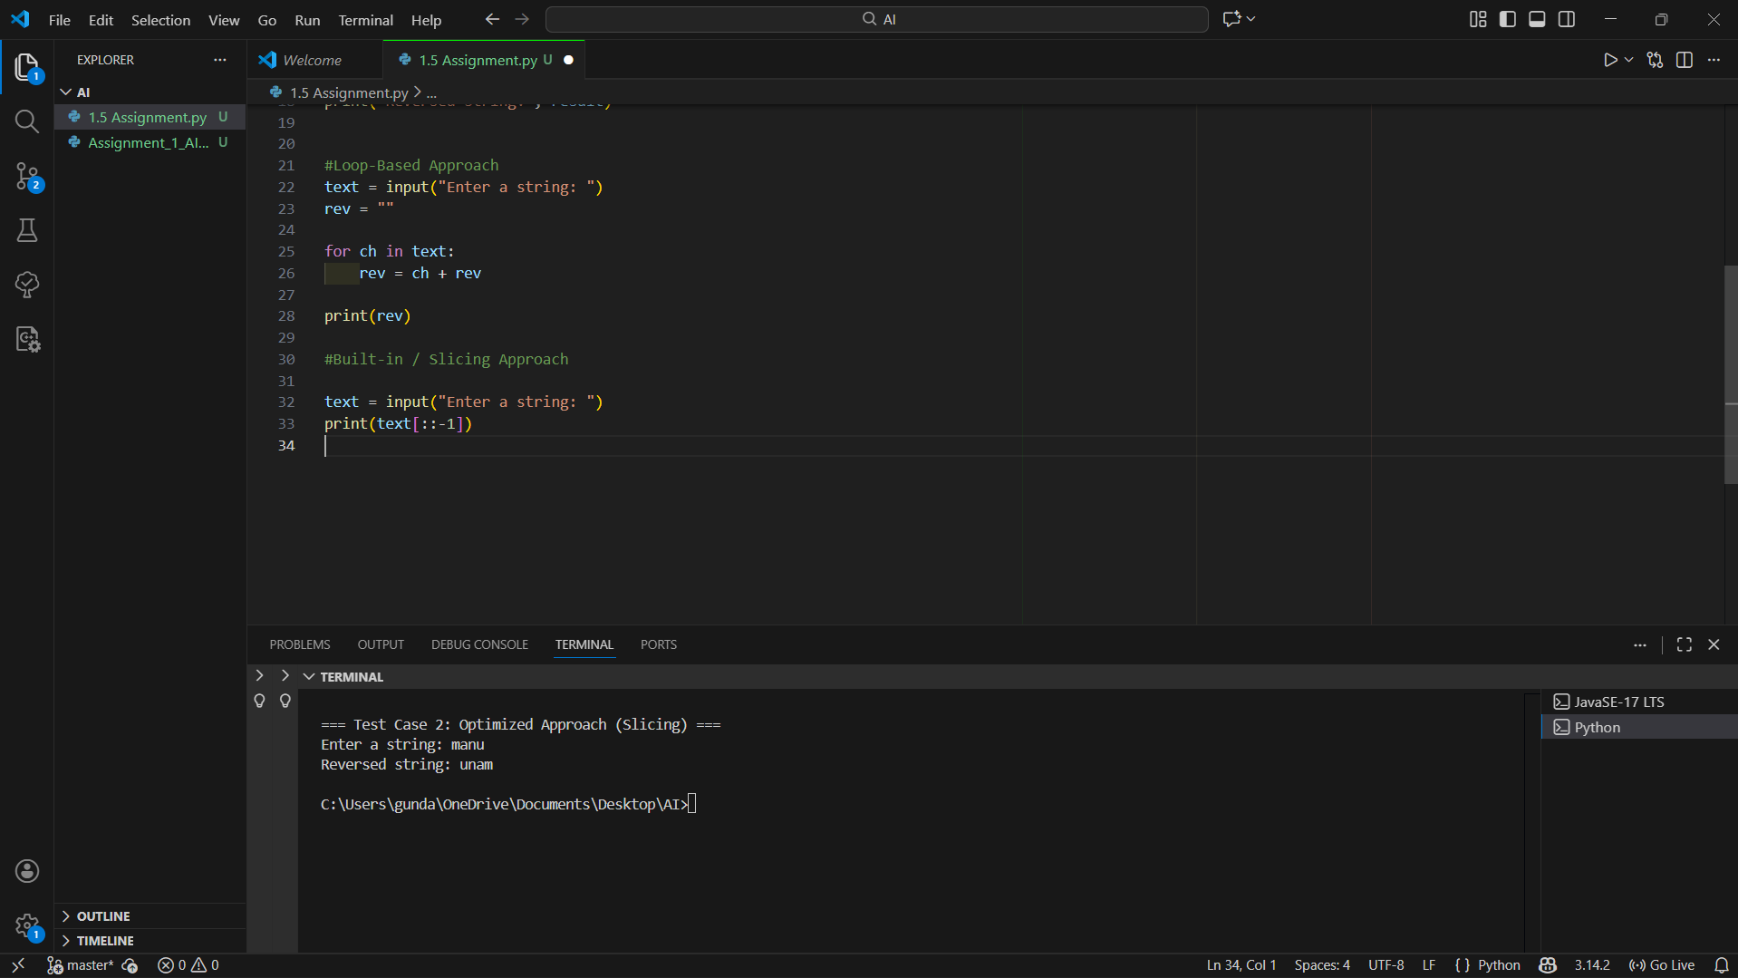
Comparison:
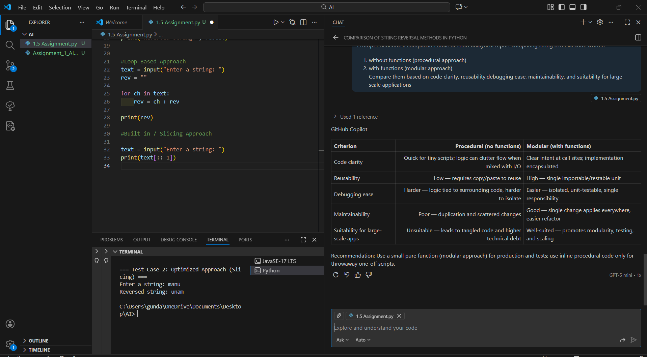
Final Conclusion
GitHub Copilot significantly enhances developer productivity by providing accurate code suggestions, improving learning speed, and promoting best practices. However, understanding logic remains essential to avoid blind dependency on AI-generated code.

